INCIDENT ASSESSMENT FORM FOR DESIGNATED OFFICERS
This tool is intended to support Designated Officers within York Region in assessing potential exposures to communicable diseases reported by Emergency Service Workers. It provides a flexible framework to guide a thorough risk assessment, allowing users to assess the relevant areas based on the specific situation.
Important Notes
- Not all questions apply to every infectious disease—use your judgment based on the case
- The tool ensures all necessary information is gathered if reporting to York Region Public Health (YRPH) if required
- Do not submit this form to YRPH; it is for internal use only

Name of Emergency Service Worker and Position:
Address of Emergency Service Worker:
Phone Number of Emergency Service Worker:
Name of Designated Officer:
Location & Address of Incident:
Date of Incident:
Time of Incident:
Date and Time Incident Assessment Form Completed: | Date: Click or tap to enter a date.  Time:

Nature of the Exposure | Please indicate the type of exposure that occurred:  ☐ Needlestick or puncture from a contaminated sharp  object  ☐ Splash to the eye from a body fluid (specify type):  ☐ Laceration or break in the skin during contact with  potentially infectious material  ☐ Splash to the mouth from a body fluid (specify type):  ☐ Exposure of non-intact skin (e.g., cuts, abrasions) to a  body fluid (specify type):  ☐ Close contact with an individual who is coughing,  possibly indicating tuberculosis (TB)  ☐ Close contact with someone suspected of having  meningococcal disease  ☐ Prolonged confinement in an enclosed space (e.g.,  vehicle, aircraft) with a coughing individual  ☐ Providing mouth-to-mouth resuscitation without a  protective mouthpiece  ☐ Bite from a human, animal, or insect  ☐ Sharing of drinking glasses, utensils, or other  personal items with a potentially infected individual  ☐ Other:
Nature of the Exposure | Please indicate which body fluid(s) the Emergency Service Worker was exposed to during the incident:  ☐ Blood  ☐ Wound drainage  ☐ Vomit  ☐ Saliva  ☐ Feces  ☐ Urine  ☐ Other (please specify):
Additional Details:

Duration of Exposure | Please provide details regarding the length of time the Emergency Service Worker was exposed to the potential source of infection. Examples include:  - Duration spent in a confined space (e.g., aircraft, vehicle) with the potentially infectious individual  - Length of time the worker’s skin or clothing was contaminated with a body fluid (specify type) before decontamination  - Any delays in removing contaminated PPE or washing affected areas  Specify exposure duration and circumstances:
Immune Status | Please confirm whether the Emergency Service Worker’s immunization is up to date for the following communicable diseases (as applicable):  ☐ Tetanus  ☐ Diphtheria  ☐ Pertussis  ☐ Measles  ☐ Mumps  ☐ Rubella  ☐ Varicella  ☐ Hepatitis A  ☐ Hepatitis B  ☐ Influenza  ☐ Meningitis  ☐ Unknown
Immune Status | Has the Emergency Service Worker completed serology to determine their immune for the communicable disease (as applicable)?  ☐ Tetanus ☐ IgG Reactive ☐ IgG Non-Reactive  ☐ Diphtheria ☐ IgG Reactive ☐ IgG Non-Reactive  ☐ Pertussis ☐ IgG Reactive ☐ IgG Non-Reactive  ☐ Measles ☐ IgG Reactive ☐ IgG Non-Reactive  ☐ Mumps ☐ IgG Reactive ☐ IgG Non-Reactive  ☐ Rubella ☐ IgG Reactive ☐ IgG Non-Reactive  ☐ Varicella ☐ IgG Reactive ☐ IgG Non-Reactive  ☐ Hepatitis A ☐ IgG Reactive ☐ IgG Non-Reactive  ☐ Hepatitis B ☐ anti-HBs Reactive ☐ anti-HBs Non-Reactive  Other:
Additional Details:

Precautions and Personal Protective Equipment | Please indicate which PPE or precautions were used by the Emergency Service Worker used during the incident:  ☐ Goggles  ☐ Gloves  ☐ Apron or protective clothing  ☐ Mask (e.g. medical mask, N95) Specify:  ☐ Other (Please describe in detail):  ☐ No barrier precautions used (if none were used, please provide additional details):
Precautions and Personal Protective Equipment | Were there any breaches in PPE?  ☐ Yes – Please describe the breach in detail:  ☐ No
Additional Information to Support Exposure Assessment | Please provide any other relevant details that may assist in evaluating the exposure risk.  This may include:  - Suspected or confirmed diagnosis of the individual involved  - Environmental conditions (e.g., cleanliness, ventilation, crowding)  - Behavioral factors (e.g., coughing, bleeding, aggressive behavior)  - Any other contextual details that may influence risk assessment
Additional Details:

Process for Designated Officers to Contact York Region Public Health (YRPH)

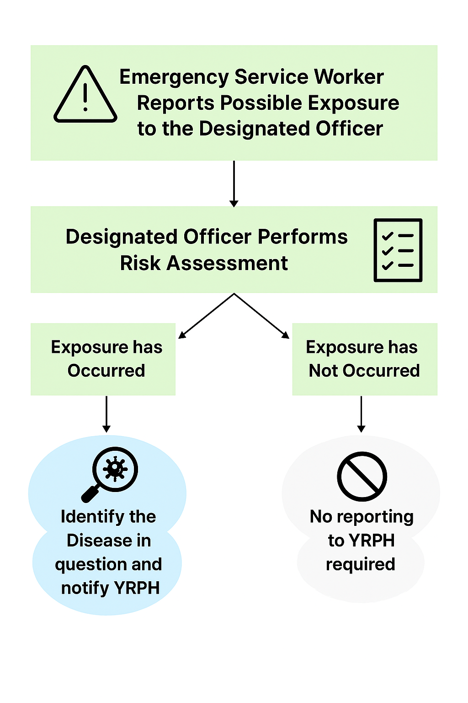
York Region Public Health Contacts for Exposures to Communicable Diseases
Communicable Disease | Contact Information
Sexual and Blood Borne Infections  (including, Hepatitis B & C, STIs, HIV/ADS) | Sexual & Blood Borne Infections (SBBI) Team  1-877-464-9675 EXT 74214 OnDutyPHN@York.ca
All Other Communicable Diseases | Control of Infectious Disease (CID) Team  1-877-464-9675 EXT 73588  CIDIntakeLine@york.ca  On-Call – 905-953-6478
Tuberculosis | Tuberculosis (TB) Team  1-877-464-9675 EXT 76000  TB@york.ca
Rabies | Health Connection Team  1-800-361-5653 x 4  Health.Inspectors@york.ca

